
2011 WATER QUALITY REPORT

CALIFORNIA STATE POLYTECHNIC UNIVERSITY, POMONA
CALIFORNIA STATE POLYTECHNIC UNIVERSITY, POMONA
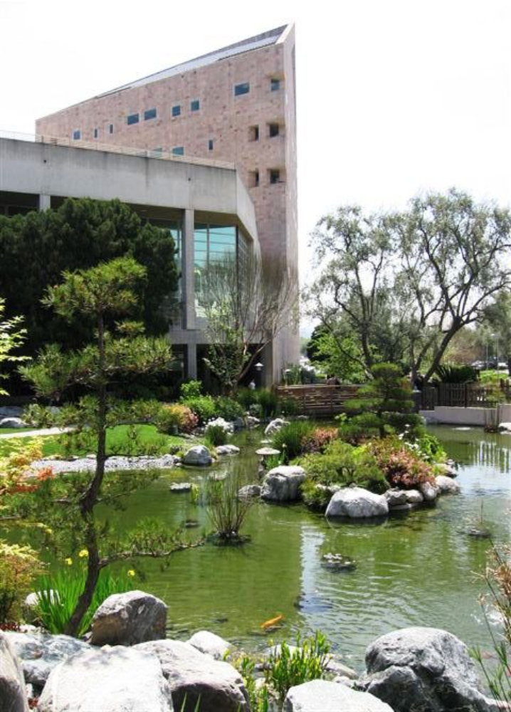

CALIFORNIA STATE POLYTECHNIC UNIVERSITY, POMONA

CALIFORNIA STATE POLYTECHNIC UNIVERSITY, POMONA
ABOUT THIS REPORT

Cal Poly Pomona (CPP) is proud to provide its 2011 Water Quality Report, which contains information about the quality of its drinking water and the efforts made to continue providing quality water to the campus. In 2011, CPP’s drinking water met or exceeded all drinking water health standards of the United States Environmental Protection Agency (USEPA) and the State of California Department of Public Health (CDPH), and there were NO violations.
The USEPA, the CDPH, and the California Public Utilities Commission (CPUC) are the agencies responsible for establishing drinking water quality standards. The drinking water delivered to campus facilities and businesses meets standards established by all three agencies. CPP uses independent, state-certified water quality laboratories for testing. In some cases, the campus goes beyond what is required to monitor for constituents (elements) that have known health risks. Unregulated contaminant monitoring helps the USEPA determine where certain contaminants may occur and whether it needs to regulate those contaminants.
This year’s report complies with the regulations of the 1996 Safe Drinking Water Act reauthorization that charges the USEPA with updating and strengthening the tap water regulatory program.
SOURCES OF WATER SUPPLY
Water supplied to CPP comes from both ground and surface water. Groundwater is supplied from a domestic well located on CPP’s property and permitted by the California Department of Public Health. Water from this well is blended with water purchased from the Metropolitan Water District of Southern California (MWD), which consists of imported surface water from the Colorado River and the State Water Project in Northern California. The quality of both the ground and surface water is presented in this report. The blended water quality and contaminant levels served to the campus are also listed for several contaminants which are of the most health risk.
In general, sources of drinking water (both tap and bottled water) include rivers, lakes, streams, ponds, reservoirs, springs and wells. As water travels over the surface of the land or through the ground, it dissolves naturally-occurring minerals and in some cases, radioactive material, and can pick up substances resulting from the presence of animals or from human activity. Contaminants that may be present in source water include:
- Microbial contaminants, such as viruses and bacteria that may come from sewage treatment plants, septic systems, agricultural livestock operations, and wildlife.
- Inorganic contaminants, such as salts and metals, that can be naturally-occurring or result from urban storm water runoff, industrial or domestic wastewater discharges, oil and gas production, mining, or farming.
- Pesticides and herbicides, that may come from a variety of sources such as agriculture, urban storm water runoff, and residential uses.

- Organic chemical contaminants, including synthetic and volatile organic chemicals that are byproducts of industrial processes and petroleum production, and can also come from gas stations, urban storm water runoff, and septic systems.
- Radioactive contaminants that can be naturally occurring or the result of oil and gas production and mining activities.

To ensure that tap water is safe to drink, the USEPA and CDPH prescribe regulations that limit the amount of certain contaminants in water provided by public water systems. The CDPH regulations also establish limits for contaminants in bottled water that must provide the same protection for public health.

Drinking water, including bottled water, may reasonably be expected to contain at least small amounts of some contaminants. The presence of contaminants does not necessarily indicate that the water poses a health risk. More information about contaminants and potential health effects can be obtained by calling the USEPA’s Safe Drinking Water Hotline (1-800-426-4791) or online at http://www.epa.gov/safewater/.
Some people may be more vulnerable to contaminants in drinking water than the general population. Immuno-compromised persons, such as persons with cancer undergoing chemotherapy, persons who have undergone organ transplants, people with HIV/AIDS or other immune system disorders, some elderly, and infants can be particularly at risk from infections. These people should seek advice about drinking water from their health care providers. The USEPA/Centers for Disease Control (CDC) guidelines on appropriate means to lessen the risk of infection by Cryptosporidium and other microbial contaminants are available from the Safe Drinking Water Hotline (1-800-426-4791) or http://www.epa.gov/safewater/.
In ongoing support of environmental sustainability, CPP recognizes its responsibilities to the global community. Water conservation information and tips are available online at http://www.bewaterwise.com/.

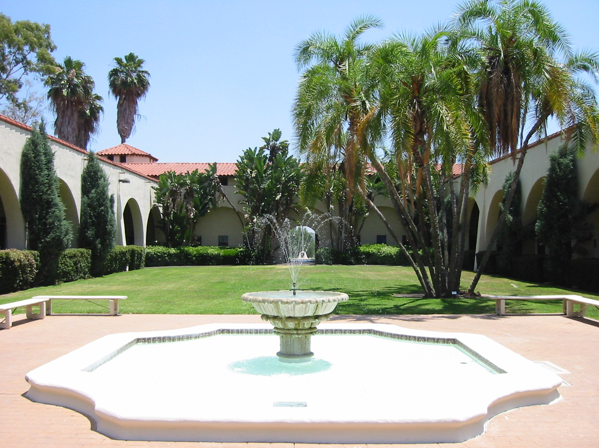

SOURCE WATER ASSESSMENTS
In July 2001, the CDPH conducted source water assessments of CPP’s groundwater sources, Wells 1 and 2, to determine the vulnerability of these water sources to possible contaminating activities. Summaries of the assessments may be requested by contacting the CDPH Chief, Los Angeles Region (1-818-551-2004). Copies of the complete assessments may be viewed at the CDPH Angeles District Office, 500 N. Central Ave., Suite 500, Glendale, CA 91203. For more information, contact Don Johnson, CPP Facilities Management (1-909-869-3042).
Based on the assessments, both water “sources are considered most vulnerable to the following activities associated with contaminants detected in the water supply: illegal and/or unauthorized dumping activities, historical and present applications of fertilizers, and [animal] grazing.” At CPP, nitrate has been the only contaminant ever detected as a result of the potential activities identified. Therefore, the nitrate level in CPP’s groundwater is continuously metered, tested, and monitored. When the nitrate reading reaches a certain level, the groundwater is blended with water supplied by MWD to keep the nitrate level below the maximum contaminant level.
The assessments further conclude that these water sources are also considered most vulnerable to the following activities not associated with any detected contaminants: sewer collection systems, chemical/petroleum processing and/or storage systems, and potential leaking underground storage tanks. Contaminants potentially associated with these activities have not been detected in CPP’s water supply.
Further Note About Vulnerabilities: The inclusion of these vulnerabilities is not to say that CPP considers itself vulnerable - these are hypothetical potential risks that were identified, not violations that have occurred. With the exception of animal grazing and fertilizers, which increase nitrates in the water, none of the risks identified have occurred. Since the 2001 assessments, CPP has implemented countermeasures to decrease its vulnerability, including increasing security, limiting access, and replacing and upgrading water monitoring systems.
In December 2002, MWD completed a source water assessment of its Colorado River and State Water Project supplies. Colorado River supplies are considered to be most vulnerable to recreation, urban/storm water runoff, increasing urbanization in the watershed, and wastewater. State Water Project supplies are considered to be most vulnerable to urban/storm water runoff, wildlife, agriculture, recreation, and wastewater. Copies of the assessments may be obtained by contacting MWD (1-213-217-6850).



WATER QUALITY MONITORING
CPP routinely monitors for contaminants in its drinking water in accordance with Federal and State laws. To minimize the presence of harmful bacteria or other pathogens, CPP is also required to continuously disinfect the water. The disinfection levels of the water system are checked daily to ensure quality. Bacteria, which may indicate potential health risks, are monitored weekly. Over 500 tests for bacteria were conducted during 2011, with NO exceeded limits found. During March of 2011, CPP exceeded the Total Trihalomethane (TTHM) standard of 80 ppb (parts per billion) by 1 ppb, and was required to develop a compliance plan. Corrections made have indicated full compliance since.
Monitoring results for the period of January 1 to December 31, 2011, are identified in the three tables located on the following pages. Table 1 contains chemicals and contaminants that have primary MCLs. Table 2 shows the monitoring results for lead and copper at the consumers’ taps. Table 3 lists chemicals and contaminants with secondary MCLs. Additional detected parameters of interest are also listed in Table 3. The definitions below are provided for terms and abbreviations contained in the tables that might be unfamiliar.
TOTAL TRIHALOMETHANES MCL VIOLATION
During March of 2011, TTHMs were found in the campus water at levels that exceeded the drinking water standard for Total Trihalomethanes (TTHMs). Water sample results received on March 8, 2011, showed TTHMs at a level of 81 parts per billion, which was above the standard or MCL of 80 parts per billion. This was due to water conservation measures performed in preparation for a 10-day shutdown of a treatment plant by MWD, which is a primary source of CPP’s water. After the shutdown, water supply levels in the campus reservoirs were adjusted back to that of normal daily operations, and the standard required has been continuously met since June of 2011. Please note that TTHMs are a byproduct of drinking water disinfection and do not pose an immediate risk. However, some people who drink water containing TTHMs in excess of the MCL over many years may experience liver, kidney or central nervous system problems, and may have an increased risk of getting cancer.
DEFINITIONS AND MEASUREMENTS
- AL = Regulatory Action Level: The concentration of a contaminant which, if exceeded, triggers treatment or other requirements which a water system must follow.
- MCL = Maximum Contaminant Level: The highest level of a contaminant that is allowed in drinking water. Primary MCLs are set as close to the PHGs (or MCLGs) as is economically and technologically feasible. Secondary MCLs are set to protect the odor, taste and appearance of drinking water.
- MCLG = Maximum Contaminant Level Goal: The level of a contaminant in drinking water below which there is no known or expected risk to health. PHGs are set by the California Environmental Protection Agency.
- MRDL = Maximum Residual Disinfection Level: The highest level of a disinfectant allowed in drinking water. There is convincing evidence that addition of a disinfectant is necessary for control of microbial contaminants.
- MRDLG = Maximum Residual Disinfection Level Goal: The level of a drinking water disinfectant below which there is no known or expected risk to health. MRDLGs do not reflect the benefits of the use of disinfectants to control microbial contaminants.
- N/A = Not Applicable: Monitoring requirements may vary between sources.
- ND = Not Detected: Laboratory analysis indicates that the constituent is not present at detectable levels.
- NL = Notification Level
- NM = Not Monitored: The source was not monitored for the constituent.
- NS = No Standard: No existing federal or state drinking water standard has been established.
- NTU = Nephelometric Turbidity Units
- PDWS = Primary Drinking Water Standard: MCLs or MRDLs for contaminants that affect health, along with their monitoring and reporting requirements and water treatment requirements.
- PHG = Public Health Goal: The level of a contaminant in drinking water below which there is no known or expected risk to health. PHGs are set by the California Environmental Protection Agency.
- pCi/L = Picocuries Per Liter: A measure of the radioactivity in water.
- ppb = Parts Per Billion: Parts per billion, or micrograms per liter (ug/L).
- ppm = Parts Per Million: Parts per million, or milligrams per liter (mg/L).
- RAA = Running Annual Average: Compliance is determined by a running annual average of all samples taken from a sampling point.
- TT = Treatment Technique: A required process intended to reduce the level of a contaminant in drinking water.
ADDITIONAL NOTES
Nitrates
CPP blends water from its approved domestic well with MWD sources to ensure that nitrates in the drinking water do not reach levels which may pose a health risk. CPP utilizes an automated control system that maintains nitrates at a level below 45 mg/L.
Nitrate in drinking water at levels above 45 mg/L is a health risk for infants of less than six months of age. Such nitrate levels in drinking water can interfere with the capacity of the infant’s blood to carry oxygen, resulting in serious illness. Symptoms include shortness of breath and blueness of the skin. Nitrate levels above 45 mg/L may also affect the ability of the blood to carry oxygen in other individuals, such as pregnant women and those with certain specific enzyme deficiencies. If you are caring for an infant, or if you are pregnant, you should seek advice from your health care provider. Nitrate levels may rise quickly for short periods of time because of rainfall or agricultural activity.

Lead
If present, elevated levels of lead can cause serious health problems, especially for pregnant women and young children. Lead in drinking water is primarily from materials and components associated with service lines and home plumbing. CPP is responsible for providing high quality drinking water, but cannot control the variety of materials used in plumbing components. When your water has been sitting for several hours, you can minimize the potential for lead exposure by flushing your tap for 30 seconds to 2 minutes before using water for drinking or cooking. If you are concerned about lead in your water, you may wish to have your water tested. Information on lead in drinking water, testing methods, and steps you can take to minimize exposure is available from the Safe Drinking Water Hotline (1-800-426-4791) or at http://www.epa.gov/safewater/lead
Lead and Copper Sampling Program
In accordance with Federal Drinking Water Standards, CPP is periodically required to sample and test the water for the presence of lead and copper. While lead and copper are not normally found in the supplied drinking water in quantities which are of any health concern, lead and copper can leach out from plumbing fixtures containing lead solder. During June 2011, CPP tested for the presence of lead and copper at 30 campus sites. Results indicated that lead and copper did not exceed the action level at any site.
Corrosion Control Program
CPP has been proactive in its investigation of lead and copper sources on campus. Sources of lead and copper in drinking water are recognized to be from plumbing fixtures or soldered fittings which may have been installed prior to 1985. CPP has identified several buildings which may have fittings containing lead or copper and, in 2006, implemented an approved corrosion control inhibitor. So far, this inhibitor has proven to eliminate or reduce both elements to levels where no action is required. Additionally, CPP has continued in 2011 to remove plumbing fixtures which may have contributed to small amounts of lead and/or copper within the buildings. CCP only installs plumbing fixtures that meet the California “Lead Free” Standards.
Turbidity
Turbidity is a measure of the cloudiness of the water. CPP monitors turbidity because it is a good indicator of water quality. High turbidity can hinder the effectiveness of disinfectants.
WATER QUALITY TABLES
The first column of each water quality table that follows lists the chemical/constituent detected in the water. The next columns list the average concentration and range of concentrations of the detected chemical. All chemicals and constituents were monitored at either the well source or from the water distribution system during 2011. Data listed for the surface water is taken from monitoring conducted during 2011 by MWD.
Also listed is the PHG (or MCLG, if applicable) established for each chemical/contaminant. The last column describes the likely source(s) of each contaminant detected in the drinking water.

CONTACTS
Before installing or modifying any equipment that utilizes the campus water in or at a building, submit a service request to Facilities Customer Service for a complimentary assessment by Facilities Management regarding federal, state and local requirements.
Facilities Customer Service
http://isd.fpm.csupomona.edu/
1-909-869-3030

If you have specific questions about the quality of the drinking water supplied on the CPP campus, please contact:

Don Johnson
Manager, Building & Mechanical Services
Facilities Management

1-909-869-3042

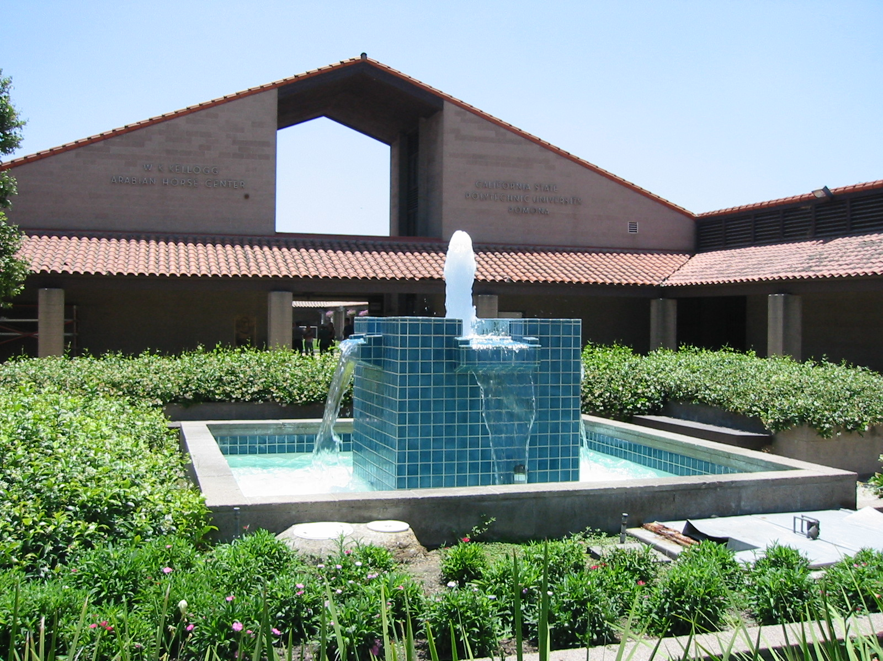

2011 WATER QUALITY DATA
The tables that follow identify all the contaminants/constituents that Cal Poly Pomona’s drinking water was tested for and the contaminants detected, if any, during the most recent monitoring done in compliance with regulations. The State allows monitoring for some contaminants less than once per year because the concentrations of these contaminants do not change frequently. Unless otherwise noted, the data presented in this table is from testing completed from January 1, 2011 through December 31, 2011. The presence of these contaminants in the water does not necessarily indicate that the water poses a health risk. For further information, see tables that follow for additional health risk statements.

KEY
(also see DEFINITIONS AND MEASUREMENTS)

AL = Regulatory Action Level | NS = No Standard
MCL = Maximum Contaminant Level | NTU = Nephelometric Turbidity Units
MCLG = Maximum Contaminant Level Goal | pCi/L = picocuries per liter (a measure of radioactivity)
MFL = million fibers per liter | PDWS = Primary Drinking Water Standard
MRDL = Maximum Residual Disinfectant Level | PHG = Public Health Goal
MRDLG = Maximum Residual Disinfectant Level Goal | ppb = parts per billion, or micrograms per liter (µg/L)
N/A = Not Applicable | ppm = parts per million, or milligrams per liter (mg/L)
ND = Not Detected | ppq = parts per quadrillion, or picograms per liter
NL = Notification Level | RAA = Running Annual Average
NM = Not Monitored | TT = Treatment Technique

TABLE 1. Regulated Contaminants with Primary MCLs, MRDLs, TTs, or ALs
Microbiological Contaminants
Chemical or Constituent (reporting units) |  | MCL  (AL)  [MRDL] |  |  |  |  | PHG  (MCLG)  [MRDLG] |  |  |  |  | MWD  Highest # of positive samples |  |  |  |  | Cal Poly Highest # of positive samples |  |  |  |  |  | Typical Sources in Drinking Water |  |  |  |  |  |  |  | Health Effects Language
Total Coliform Bacteria  (Total Coliform Rule)  (number of positive samples in any one month) |  | More than 5% of monthly samples are positive. |  |  |  |  | (0) |  |  |  |  | 0 |  |  |  |  | 0 |  |  |  |  |  | Naturally present in the environment. |  |  |  |  |  |  |  | Coliforms are bacteria that are naturally present in the environment and are used as an indicator that other, potentially-harmful, bacteria may be present.
Fecal Coliform or E.coli  (Total Coliform Rule)  (number of positive samples during the year) |  | A routine sample and a repeat sample are total coliform positive, and one of these is also fecal coliform or E.coli positive |  |  |  |  | (0) |  |  |  |  | 0 |  |  |  |  | 0 |  |  |  |  |  | Human and animal fecal waste. |  |  |  |  |  |  |  | Fecal coliforms and E. coli are bacteria whose presence indicates that the water may be contaminated with human or animal wastes. Microbes in these wastes can cause short-term effects, such as diarrhea, cramps, nausea, headaches, or other symptoms. They may pose a special health risk for infants, young children, and people with severely compromised immune systems.
Fecal Indicators  E. coli  (enterococci or coliphage)  (Ground Water Rule) |  | 0  TT |  |  |  |  | (0)  N/A |  |  |  |  | 0  0 |  |  |  |  | 0  0 |  |  |  |  |  | Human and animal fecal waste.  Human and animal fecal waste. |  |  |  |  |  |  |  | Fecal indicators are microbes whose presence indicates that the water may be contaminated with human or animal wastes. Microbes in these wastes can cause short-term effects, such as diarrhea, cramps, nausea, headaches, or other symptoms. They may pose a special health risk for infants, young children, some of the elderly, and people with severely compromised immune systems.
Disinfection Byproducts, Disinfectant Residuals, and Disinfection Byproducts Precursors
Chemical or Constituent (reporting units) | MCL  (AL)  [MRDL] |  |  |  | PHG  (MCLG)  [MRDLG] |  |  |  |  | MWD Supply |  |  |  |  |  |  |  |  |  |  | Cal Poly System |  |  |  |  |  | Typical Sources in Drinking Water |  |  | Health Effects Language
Chemical or Constituent (reporting units) |  |  |  |  |  |  |  |  |  | Range |  |  |  |  |  | Highest RAA (d) |  |  |  |  | Range |  |  | Highest RAA (d)
Total Trihalomethanes (TTHMs) (ppb) | 80 |  |  |  | N/A |  |  |  |  | 48 - 68 |  |  |  |  |  | 43 |  |  |  |  | 40 - 100 |  |  | 81* |  |  |  | Byproduct of drinking water disinfection. |  | Some people who drink water containing trihalomethanes in excess of the MCL over many years may experience liver, kidney or central nervous system problems, and may have an increased risk of getting cancer.
Haloacetic Acids (HAA5s) (ppb) | 60 |  |  |  | N/A |  |  |  |  | 17 - 33 |  |  |  |  |  | 15 |  |  |  |  | 17 - 50 |  |  | 32 |  |  |  | Byproduct of drinking water disinfection. |  | Some people who drink water containing haloacetic acids in excess of the MCL over many years may have an increased risk of getting cancer.
Total Chlorine Residual (ppm) | [4.0 (as Cl₂₎] |  |  |  | [4 (as Cl₂₎] |  |  |  |  | 1.3 - 2.0 |  |  |  |  |  | 2.3 |  |  |  |  | 0.4 - 0.98 |  |  | 0.64 |  |  |  | Drinking water disinfectant added for treatment. |  | Some people who use water containing chlorine well in excess of the MRDL could experience irritating effects to their eyes and nose. Some people who drink water containing chlorine well in excess of the MRDL could experience stomach discomfort.
Organic Contaminants
Chemical or Constituent (reporting units) | MCL  (AL) |  |  |  | PHG  (MCLG) |  |  |  |  |  | MWD Supply |  |  |  |  |  |  |  |  |  | Cal Poly System |  |  |  |  |  | Typical Sources in Drinking Water |  |  | Health Effects Language
Chemical or Constituent (reporting units) |  |  |  |  |  |  |  |  |  |  | Range |  |  |  |  | Average |  |  |  |  | Range |  |  | Average
Trichloroethylene [TCE] (ppb) | 5 |  |  |  | 1.7 |  |  |  |  |  | ND |  |  |  |  | ND |  |  |  |  | ND |  |  | ND |  |  | Discharge from metal degreasing sites and other factories. |  |  | Some people who use water containing trichloroethylene in excess of the MCL over many years may experience liver problems and may have an increased risk of getting cancer.
Inorganic Contaminants
Chemical or Constituent (reporting units) | MCL  (AL) |  |  |  |  | PHG  (MCLG) |  |  |  | MWD Supply |  |  |  |  |  |  |  |  |  | Cal Poly System |  |  |  |  |  | Typical Sources in Drinking Water |  |  | Health Effects Language
Chemical or Constituent (reporting units) |  |  |  |  |  |  |  |  |  | Range |  |  |  |  | Average |  |  |  |  | Range |  |  | Average
Aluminum (ppb) | 1000 |  |  |  |  | 600 |  |  |  | ND – 220 |  |  |  |  | 170 |  |  |  |  | ND |  |  | ND |  |  | Erosion of natural deposits; residue from some surface water treatment processes. |  |  | Some people who drink water containing aluminum in excess of the MCL over many years may experience short-term gastrointestinal tract effects.
Arsenic (ppb) | 10 |  |  |  |  | 0.004 |  |  |  | ND |  |  |  |  | ND |  |  |  |  | ND |  |  | ND |  |  | Erosion of natural deposits; runoff from orchards; glass and electronics production wastes. |  |  | Some people who drink water containing arsenic in excess of the MCL over many years may experience skin damage or circulatory system problems, and may have an increased risk of getting cancer.
Barium (ppb) | 1000 |  |  |  |  | 2000 |  |  |  | ND |  |  |  |  | ND |  |  |  |  | 110 |  |  | 110 |  |  | Discharges of oil drilling wastes and from metal refineries; erosion of natural deposits. |  |  | Some people who drink water containing barium in excess of the MCL over many years may experience an increase in blood pressure.
Fluoride (ppm) | 2 |  |  |  |  | 1 |  |  |  | 0.7 - 1.0 |  |  |  |  | 0.8 |  |  |  |  | 0.3 |  |  | 0.3 |  |  | Erosion of natural deposits; water additive that promotes strong teeth; discharge from fertilizer and aluminum factories. |  |  | Some people who drink water containing fluoride in excess of the federal MCL of 4 mg/L over many years may get bone disease, including pain and tenderness of the bones. Children who drink water containing fluoride in excess of the state MCL of 2 mg/L may get mottled teeth.
Nitrate (ppm)  Note: Groundwater and surface water are blended before distribution to the campus to ensure water quality. | 45  (as nitrate) |  |  |  |  | 45  (as nitrate) |  |  |  | 1.4 - 2.2 |  |  |  |  | 1.8 |  |  |  |  | 52 - 57 |  |  | 54  27.0 (b) |  |  | Runoff and leaching from fertilizer use; leaching from septic tanks and sewage; erosion of natural deposits. |  |  | Infants below the age of six months who drink water containing nitrate in excess of the MCL may quickly become seriously ill and, if untreated, may die because high nitrate levels can interfere with the capacity of the infant’s blood to carry oxygen. Symptoms include shortness of breath and blueness of the skin. High nitrate levels may also affect the oxygen-carrying ability of the blood of pregnant women.
Perchlorate (ppb)  Note: Groundwater and surface water are blended before distribution to the campus to ensure water quality. | 6 |  |  |  |  | 6 |  |  |  | ND |  |  |  |  | ND |  |  |  |  | 4.5 - 6.0 |  |  | 5.1  ND (b) |  |  | Perchlorate is an inorganic chemical used in solid rocket propellant, fireworks, explosives, flares, matches, and a variety of industries. It usually gets into drinking water as a result of environmental contamination from historic aerospace or other industrial operations that used or use, store, or dispose of perchlorate and its salts. |  |  | Perchlorate has been shown to interfere with uptake of iodide by the thyroid gland, and to thereby reduce the production of thyroid hormones, leading to adverse affects associated with inadequate hormone levels. Thyroid hormones are needed for normal prenatal growth and development of the fetus, as well as for normal growth and development in the infant and child. In adults, thyroid hormones are needed for normal metabolism and mental function.
Radioactive Contaminants
Chemical or Constituent (reporting units) |  |  |  | MCL  (AL) | PHG  (MCLG) |  |  | MWD Supply |  |  |  |  |  |  |  |  |  |  | Cal Poly System |  |  |  |  |  |  |  | Typical Sources in Drinking Water |  | Health Effects Language
 |  |  |  | MCL  (AL) |  |  |  | Range |  |  |  |  | Average |  |  |  |  |  | Range |  |  | Average
Gross Alpha Particle Activity  (pCi/L) |  |  |  | 15 | (0) |  |  | ND – 3.0 |  |  |  |  | ND |  |  |  |  |  | NS |  |  | NS |  |  |  |  | Erosion of natural deposits. |  | Certain minerals are radioactive and may emit a form of radiation known as alpha radiation. Some people who drink water containing alpha emitters in excess of the MCL over many years may have an increased risk of getting cancer.
Gross Beta Particle Activity  (pCi/L) |  |  |  | 50^{(f)} | (0) |  |  | ND – 6.0 |  |  |  |  | 4.0 |  |  |  |  |  | NS |  |  | NS |  |  |  |  | Decay of natural and man-made deposits. |  | Certain minerals are radioactive and may emit forms of radiation known as photons and beta radiation. Some people who drink water containing beta and photon emitters in excess of the MCL over many years may have an increased risk of getting cancer.
Uranium (pCi/L) |  |  |  | 20 | 0.43 |  |  | 1 - 2 |  |  |  |  | 2 |  |  |  |  |  | NS |  |  | NS |  |  |  |  | Erosion of natural deposits. |  | Some people who drink water containing uranium in excess of the MCL over many years may have kidney problems or an increased risk of getting cancer.
TABLE 2. Lead and Copper Monitoring at Consumer’s Tap
Chemical or Constituent (reporting units) |  |  |  | MCL  (AL) | PHG  (MCLG) |  |  | MWD Supply |  |  |  |  |  |  |  |  |  |  | Cal Poly System |  |  |  |  |  |  |  | Typical Sources in Drinking Water |  | Health Effects Language
 |  |  |  | MCL  (AL) |  |  |  | 90th  Percentile |  |  |  |  | # of samples  >AL |  |  |  |  |  | 90th  Percentile |  |  |  |  |  | # of samples >AL
Lead (ppb) |  |  |  | (15) | 0.2 |  |  | ND |  |  |  |  | 0 |  |  |  |  |  | <5 (c) |  |  |  |  |  | 0 |  | Internal corrosion of household water plumbing systems; discharges from industrial manu-facturers; erosion of natural deposits. |  | Infants and children who drink water containing lead in excess of the action level may experience delays in their physical or mental development. Children may show slight deficits in attention span and learning abilities. Adults who drink this water over many years may develop kidney problems or high blood pressure.
Copper (ppb) |  |  |  | (1,300) | 300 |  |  | ND |  |  |  |  | 0 |  |  |  |  |  | 50 (c) |  |  |  |  |  | 0 |  | Internal corrosion of household plumbing systems; erosion of natural deposits; leaching from wood preservatives. |  | Copper is an essential nutrient, but some people who drink water containing copper in excess of the action level over a relatively short amount of time may experience gastrointestinal distress. Some people who drink water containing copper in excess of the action level over many years may suffer liver or kidney damage. People with Wilson’s Disease should consult their personal doctor.
Table 3. Regulated Contaminants with Secondary MCLs (a), unregulated, and other parameters
Chemical or Constituent (reporting units) |  |  | MCL  (Secondary MCL) |  | PHG  (MCLG) |  |  |  | MWD Supply |  |  |  |  |  |  |  |  | Cal Poly System |  |  |  |  |  |  |  |  | Typical Sources in Drinking Water |  | Health Effects Language
 |  |  |  |  |  |  |  |  | Range |  |  |  |  | Avg |  |  |  | Range |  |  |  |  |  |  | Average
Chloride (ppm) |  |  | (500) |  | NA |  |  |  | 63 - 76 |  |  |  |  | 70 |  |  |  |  |  |  |  |  |  |  | 77 |  | Runoff/leaching from natural deposits; seawater influence. |  | N/A
Color (units) |  |  | (15) |  | NA |  |  |  | 1 - 2 |  |  |  |  | 2 |  |  |  | ND |  |  |  |  |  |  | 0 |  | Naturally-occurring organic materials. |  | N/A
Hardness (ppm) |  |  | NA |  | NA |  |  |  | 84 - 300 |  |  |  |  | 260 |  |  |  |  |  |  |  |  |  |  | 550 |  | Sum of polyvalent cations present in the water, generally magnesium and calcium, and are usually naturally occurring. |  | N/A
Odor Threshold (units) |  |  | (3) |  | NA |  |  |  | < 1 - 2 |  |  |  |  | 2 |  |  |  | ND |  |  |  |  |  |  | ND |  | Naturally-occurring organic materials. |  | N/A
Sodium (ppm) |  |  | NA |  | NA |  |  |  | 83 - 98 |  |  |  |  | 94 |  |  |  |  |  |  |  |  |  |  | 41 |  | Salt present in the water and is generally naturally occurring. |  | N/A
Sulfate (ppm) |  |  | (500) |  | NA |  |  |  | 120 - 170 |  |  |  |  | 150 |  |  |  |  |  |  |  |  |  |  | 190 |  | Runoff/leaching from natural deposits; industrial wastes. |  | N/A
Turbidity (NTU) |  |  | (5) |  | NA |  |  |  | < 0.05 – 0.06 |  |  |  |  | 0.06 |  |  |  | ND - 2.7 |  |  |  |  |  |  | 0.20 |  | Soil runoff. |  | Turbidity has no health effects. However, high levels of turbidity can interfere with disinfection and provide a medium for microbial growth. Turbidity may indicate the presence of disease-causing organisms. These organisms include bacteria, viruses, and parasites that can cause symptoms such as nausea, cramps, diarrhea, and associated headaches.
Total Dissolved Solids (ppm) |  |  | (1,000) |  | NA |  |  |  | 390 - 480 |  |  |  |  | 440 |  |  |  |  |  |  |  |  |  |  | 740 |  | Runoff/leaching from natural deposits. |  | N/A
Unregulated
Chemical or Constituent (reporting units) |  | MCL  (Secondary MCL) |  |  | PHG  (MCLG) |  |  |  | MWD Supply |  |  |  |  |  |  |  |  |  | Cal Poly System |  |  |  |  |  |  |  | Typical Sources in Drinking Water |  | Health Effects Language
 |  |  |  |  |  |  |  |  | Range |  |  |  |  |  | Avg |  |  |  | Range |  |  |  |  |  | Average
Boron (ppb) |  | NL = 1,000 |  |  | NL= 1,000 |  |  |  | 120 - 140 |  |  |  |  |  | 130 |  |  | NS |  |  |  |  |  |  | NS |  | N/A |  | The babies of some pregnant women who drink water containing boron in excess of the notification level may have an increased risk of developmental effects, based on studies in laboratory animals.
Vanadium (ppb) |  | NL = 50 |  |  | NL = 50 |  |  |  | ND - 3.1 |  |  |  |  |  | ND |  |  | NS |  |  |  |  |  |  | NS |  | N/A |  | The babies of some pregnant women who drink water containing vanadium in excess of the notification level may have an increased risk of developmental effects, based on studies in laboratory animals.
L

- There are no PHGs, MCLGs, or mandatory standard health effects language for these constituents because secondary MCLs are set on the basis of aesthetics.
- Based on weekly sampling of blend of well water and MWD water that is supplied to the campus.
- Results listed for lead and copper are 90th percentile and exceeded values determined from 30 samples collected within CPP’s distribution system.
- Compliance is determined by a running annual average of all the samples taken from a sampling point.
- Effective 6/11/2006, the gross beta particle activity MCL is 4 millirems/year annual dose equivalent to the total body or any internal organ. 50 pCi/L is used as a screening level.

*Any violation of an MCL or AL is asterisked. Additional information regarding the violation is provided elsewhere in this report.

