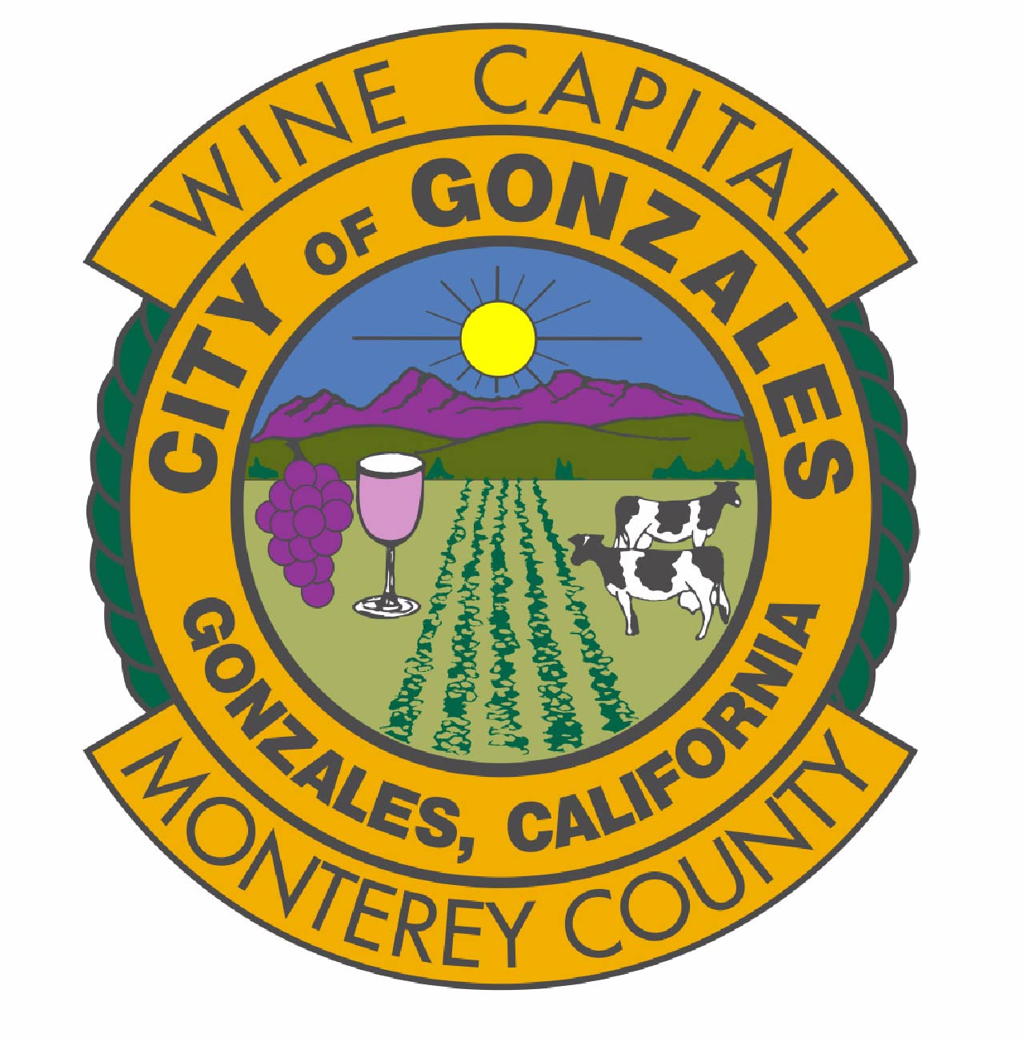 ANNUAL WATER QUALITY REPORT 2015

REPORTE DE SISTEMA DE AGUA– 2015
Este informe contiene información muy importante sobre su agua de beber. Tradúzcalo ó hable con alguien que lo entienda bien.
Dear Gonzales Resident:

The City of Gonzales is committed to providing a safe, reliable supply of excellent quality drinking water that meets Federal and State regulations. This brochure is a snapshot of the quality of water that we provided in 2015. Included are the details about where your water comes from, what it contains and how it compares to State standards. We are committed to providing you with information because informed customers are the best allies. The City encourages public interest and participation in decisions affecting the community’s drinking water supply. Our City Council meets at 6:00 P.M. on the first and third Monday of each month at 117 Fourth Street in the City Council Chambers. The City of Gonzales will take any steps necessary to ensure that your water will continue to meet safe drinking water standards.

Sincerely,
René L. Mendez
City Manager

The California Department of Public Health (CDPH), Drinking Water Field Operations Branch, requires water agencies to annually notify their customers of the constituents or elements in their drinking water. This is not the result of punitive action, nor is it indicative of any violation of treatment practices. It is strictly a mandated public information service legislated to keep you informed each year of the facts about your drinking water.

Water System

The City of Gonzales derives its water supply from ground-water sources within the Salinas Valley groundwater basin. About 530,000 acre-feet of water per year are pumped from the Salinas Valley groundwater basin, 95% of which is used for irrigated agriculture. The remaining 5% are used for municipal and industrial purposes, serving a population of approximately 150,000 people. The city currently operates 4 deep-water wells located throughout the city. In 2015, these 4 wells supplied 1369 acre-feet or 446 million gallons of water for Gonzales’ 8,357 residents. After the water comes out of these wells, we treat it with chlorine for disinfection to protect against microbial contaminants

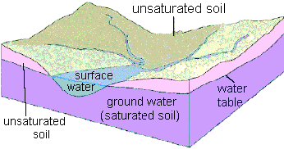

System Improvement

To meet the needs of our customers the City of Gonzales is continually developing and improving our water system. There are 7 million gallons of storage capacity. Gonzales now has computer controlled pumps to better monitor their system operations.
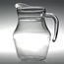
Water Quality - A National Priority
The safety of public water supplies has received much attention in recent years. The City of Gonzales customers should know that our water supply is safe and meets all drinking water standards. Sources of drinking water (both tap water and bottled water) include rivers, lakes, streams, ponds, reservoirs, springs, and wells. As water travels over the surface of the land or through the ground, it dissolves naturally occurring minerals and, in some cases, radioactive material, and can pick up substances resulting from the presence of animals or from human activity.

Some people may be more vulnerable to contaminants in drinking water than the general population. Immuno-compromised persons such as persons with cancer undergoing chemotherapy, persons who have undergone organ transplants people with HIV/AIDS or other immune system disorders, some elderly, and infants can be particularly at risk from infections. These people should seek the advice about drinking water from their health care providers. EPA/ CDC guidelines on appropriate means to lessen the risk of infection by Cryptosporidium and other microbial contaminants are available from the Safe Drinking Water Hotline (1-800-426-4791).
Contaminants that may be present in source water before we treat it include:

Microbial contaminants, such as viruses and bacteria, which may come from septic systems, agricultural livestock operations and wildlife.
Inorganic contaminants, such as salts and metals, which can be naturally occurring or result from storm water runoff, industrial or domestic wastewater discharges or farming.
Pesticides and herbicides, which may come from a variety of sources such as agricultural and residential uses.
Organic chemical contaminants including synthetic and volatile organic chemicals that are byproducts of industrial processes and petroleum production, and can also come from gas station, urban runoff, and septic systems.
Radioactive contaminants, which are naturally occurring.

California drinking water regulations require that water delivered by public water systems be, at all times, pure, wholesome and potable, as required by the federal and state Safe Drinking Water Acts. To accomplish this mandate, domestic water must meet strict standards, as provided in the California Domestic Water Quality and Monitoring Regulations.

This regulation includes primary and secondary maximum contaminant levels (MCL) and monitoring frequencies for specified microbiological, chemical and radionuclide contaminants. Primary contaminants are those, which may have an adverse health effect. Secondary contaminants are those, which may adversely affect the aesthetic quality of the drinking water. The regulation includes the provisions adopted by the federal Safe Drinking Water Act of 1974. The state has direct enforcement responsibility for all public water systems with 200 or more service connections.

The Environmental Protection Agency (EPA) establishes monitoring requirements and maximum contaminant levels. As the EPA develops new standards, California will amend state regulations, which establish water quality requirements for local water supplies. This report includes the respective public health goal (PHG), or the federal maximum contaminant level goal (MCLG) for chemicals that do not yet have a PHG.

Water Quality Data

The following table lists the drinking water contaminants detected during the 2015 calendar year. In order to ensure that tap water is safe to drink, the California Department of Health Services prescribes regulations, which limit the amount of certain contaminants in water provided by public water systems. We treat our water according to the Departments regulations. The Department’s Food and Drug Branch regulations establish limits for contaminants in bottled water, which must provide the same protection for the public. Drinking water, including bottled water, may reasonably be expected to contain at least small amounts of some contaminants.

The presence of contaminants does not necessarily indicate that water poses a health risk. More information about contaminants and potential health effects can be obtained by calling the USEPA’s Safe Drinking Water Hotline (1-800-426-4791). The presence of these contaminants in the water does not necessarily indicate that the water poses a health risk. Unless otherwise noted, the data presented in this table is from testing done January 1-December 31, 2015. The State requires us to monitor for certain contaminants less than once per year because the concentrations of these contaminants are not expected to vary significantly from year to year. Some of the data, though representative of the water quality, is more than a year old.

PRSRT STD
U.S. POSTAGE PAID
GONZALES, CA
PERMIT NO.8

City of Gonzales
P.O. Box 647
Gonzales, CA 93926

SUMMARY OF WATER QUALITY DATA FOR THE YEAR 2015

Primary Standards – Mandated Health Related Standards
Contaminant | Violation  Y/N | Level Detected |  |  | MCL | PHG | Likely Source of Contamination

Microbiological Contaminants
Total Coliform Bacteria | N | 0 |  |  | 1/month | 0 | Naturally Present in the Environment
Fecal Coliform and E. coli | N | 0 |  |  | 0 | 0 | Human and animal fecal waste
Contaminant | Violation  Y/N | Ave Level Detected* | Result Range | Units | MCL | PHG | Likely Source of Contamination
Radioactive Contaminants
Gross Alpha Activity ^ | N | 2.93 | 1.0 – 7.4 | pCi/L | 15 | N/A | Erosion of natural deposits

Inorganic Contaminants*
Fluoride | N | 0.16 | 0.15 - 0.18 | ppm | 2.0 | 1.0 | Erosion of natural deposits; discharge from fertilizer and aluminum factories
Hexavalent Chromium** | N | 2.8 | 0.2 – 4.6 | ppb | 10 | .02 | Discharge from electroplating factories, leather tanneries, wood preservation, chemical synthesis, refractory production, and textile manufacturing facilities; erosion of natural deposits
Nitrate (as N03)** | N | 10.6 | 2 – 26 | ppm | 45 | 45 | Runoff and leaching from fertilizer use; leaching from septic tanks and sewage; erosion of natural deposits

Secondary Standards* - Aesthetic Standards
Chloride | N | 32 | 15 - 58 | ppm | 500 | N/A | Runoff/leaching from natural deposits; sea water influence
Color | N | 9 | <2 - 30 | Units | 15 | N/A | Naturally-occurring organic materials
Iron | Y | 1100 | ND - 2800 | ppb | 300 | N/A | Leaching from natural deposits; industrial wastes
Manganese | N | 41 | <20 - 82 | ppb | 50 | N/A | Leaching from natural deposits
Odor—Threshold | N | 1 | 1 | TON | 3 | N/A | Naturally-occurring organic materials
Specific Conductance | N | 586 | 470 - 772 | umho/cm | 1,600 | N/A | Substances that form natural deposits; sea water influence
Sulfate | N | 99 | 80 - 126 | ppm | 500 | N/A | Runoff/leaching from natural deposits; industrial wastes
Total Dissolved Solids | N | 396 | 328 – 510 | ppm | 1,000 | N/A | Runoff/ leaching from natural deposits; seawater influence
Turbidity | N | 5.6 | 0.1 – 16 | NTU | 5 | N/A | Soil runoff

Other Constituents*
Sodium | N | 39 | 26 - 61 | ppm | N/A | N/A | Generally found in ground and surface water; seawater influence
Hardness | N | 212 | 178 - 256 | ppm | N/A | N/A | Generally found in ground and surface water.  Divide these numbers by 17.1 to get grains/gallon.
pH | N | 7.5 | 7.3 - 7.7 | Units | N/A | N/A | Inherent characteristic of water.

Disinfection Byproducts and Disinfectant Residuals
Haloacetic Acids | N | ND | ND | ppb | 60 | N/A | By-product of drinking water disinfection
TTHMs – Total Trihalomethanes | N | ND | ND | ppb | 80 | N/A | By-product of drinking water chlorination
Residual Chlorine | N | 0.24 | 0.0 – 0.83 | ppm | MRDL  4 as Cl₂ | MRDLG  4 as Cl₂ | Drinking water disinfectant added for treatment
LEAD AND COPPER*** | # Of Samples Collected | 90th Percentile Level | # Of Sites Exceeding AL | Units | Action  Level  (AL) | PHG | Typical Source of Contaminant
Lead | 18 | ND | 0 | ppb | 15 | 0.2 | Internal corrosion of household water plumbing systems; discharges from industrial manufacturers; erosion of natural deposits
Copper | 18 | 102 | 0 | ppb | 1300 | 300 | Internal corrosion of household water plumbing systems; erosion of natural deposits; leaching from wood preservatives
* Wells 3,4 & 5 tested in 2014, Well 6 in 2015 unless otherwise noted. **All Wells tested 2014. ***Lead & Copper in the distribution system monitored in 2013.
^ Analysis done in 2006 for Well 3, 2015 for Wells 4 and 5, 2014 for Well 6.
Key To Table
N/A: Not Applicable NTU: Nephleometric Turbidity Units MCL: Maximum Contaminant Level
ND: Not Detectable at testing limit pCi/l: Pico curies per liter (a measure of radiation) PHG: Public Health Goal
ppb: parts per billion or micrograms per liter TON: Threshold Odor Number MRDL(G): Maximum Residual Disinfectant Level (Goal)
ppm: parts per million or milligrams per liter MFL: Million Fibers per Liter, with a fiber length greater than 10 micrometers
Additional information about the content of this report (and additional copies) can be obtained by calling Gonzales City Hall at (831) 675-5000.

Definitions
- Maximum Contaminant Level (MCL): The highest level of a contaminant that is allowed in drinking water. Primary MCLs are set as close to the PHGs (or MCLGs) as is economically and technologically feasible. Secondary MCLs are set to protect the odor, taste, and appearance of drinking water.
- Maximum Contaminant Level Goal (MCLG): The level of a contaminant in drinking water below which there is no known or expected risk to health. MCLGs are set by the U.S. Environmental Protection Agency.
- Public Health Goal (PHG): The level of a contaminant in drinking water below which there is no known or expected risk to health. PHGs are set by the California Environmental Protection Agency.
- Primary Drinking Water Standard (PDWS): MCLs and MRDLs for contaminants that affect health along with their monitoring and reporting requirements, and water treatment requirements.
- Maximum Residual Disinfectant Level (MRDL): The highest level of a disinfectant allowed in drinking water. There is convincing evidence that addition of a disinfectant is necessary for control of microbial contaminants.
- Maximum Residual Disinfectant Level Goal (MRDLG): The level of a drinking water disinfectant below which there is no known or expected risk to health. MRDLGs do not reflect the benefits of the use of disinfectants to control microbial contaminants.
- Regulatory Action Level: The concentration of a contaminant which, if exceeded, triggers treatment or other requirements that a water system must follow.
- Treatment Technique (TT): A required process intended to reduce the level of a contaminant in drinking water.
If present, elevated levels of lead can cause serious health problems, especially for pregnant women and young children. Lead in drinking water is primarily from materials and components associated with service lines and home plumbing. City of Gonzales is responsible for providing high quality drinking water, but cannot control the variety of materials used in plumbing components. When your water has been sitting for several hours, you can minimize the potential for lead exposure by flushing your tap for 30 seconds to 2 minutes before using water for drinking or cooking. If you are concerned about lead in your water, you may wish to have your water tested. Information on lead in drinking water, testing methods, and steps you can take to minimize exposure is available from the Safe Drinking Water Hotline or at http://www.epa.gov/safewater/lead.
Iron was found at levels that exceed the secondary MCL of 300 ug/L. The iron MCL was set to protect you against unpleasant aesthetic effects (e.g., color, taste, and odor) and the staining of plumbing fixtures (e.g., tubs and sinks) and clothing while washing. The high iron levels are due to leaching of natural deposits.

Source Water Protection Tips for Consumers
Protection of drinking water is everyone’s responsibility. You can help protect your community’s drinking water source in several ways:

- Eliminate excess use of law and garden fertilizers and pesticides – they contain hazardous chemicals that can reach your drinking water source.
- Pick up after your pets.
- Dispose of chemicals properly; take used motor oil to a recycling center.
- Volunteer in your community. Gonzales has several cleanup events that are listed on the community calendar. These prevent pollution of groundwater. (www.ci.gonzales.ca.us/calendar.php)
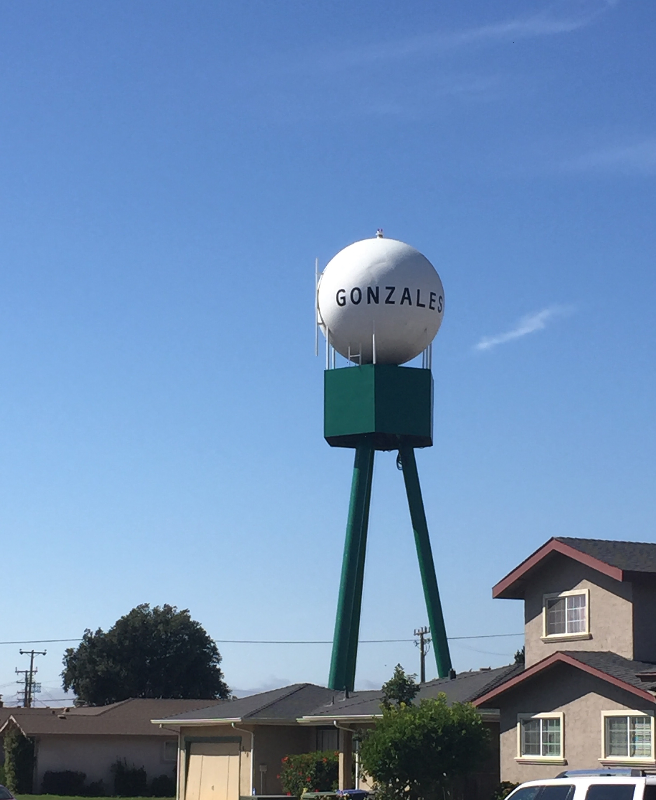

Water Conservation Tips for Consumers
Did you know that the average U.S. household uses approximately 400 gallons of water per day or 100 gallons per person per day? Luckily, there are many low-cost and no-cost ways to conserve water. Small changes can make a big difference – try one today and soon it will become second nature.

- Take shorter showers – a 5 minute shower uses 4 to 5 gallons of water compared to up to 50 gallons for a bath.
- Shut off water while brushing your teeth, washing your hair and shaving and save up to 500 gallons a month.
- Install water-efficient showerheads. They are inexpensive, easy to install, and can save you up to 750 gallons a month.
- Run your clothes washer and dishwasher only when they are full. You can save up to 1,000 gallons a month.
- Water plants only when necessary.
- Fix leaking toilets and faucets. Faucet washers are inexpensive and take only a few minutes to replace. To check your toilet for a leak, place a few drops of food coloring in the tank and wait. If it seeps into the toilet bowl without flushing, you have a leak. Fixing it or replacing it with a new, more efficient model can save up to 1,000 gallons a month.
- Adjust sprinklers so only your lawn is watered. Apply water only as fast as the soil can absorb it and during the cooler parts of the day to reduce evaporation. Gonzales has only two days a week permitted for outdoor irrigation, Wednesdays and Sundays.
- Teach your kids about water conservation to ensure a future generation that uses water wisely. Make it a family effort to reduce next month’s water bill!
Contact city staff at (831) 675-5000 with any questions on the water supply.

Visit www.epa.gov/watersense for more information.

