Pinecrest Permittees Association
System Number: 5510004
2016
Consumer Confidence Report
Where does my water come from:
Our water comes from two wells and three surface sources. The wells are located near Camp Chinquapin and off of Meadowview Road. The surface sources are Pinecrest Lake, the North Fork of the Tuolumne and Sheering Creek. Water from the wells flows directly into the systems with disinfection chemicals added. The surface water sources are filtered and disinfected before the water enters the system. An assessment of our source water was completed in June of 2011.
Source water assessment and its availability:
The lake source is considered most vulnerable to the following activities not associated with any detected contaminants: recreational area, sewer collection systems. The North Fork and Sheering Creek sources are not considered vulnerable to any potential contaminating activities at this time. A completed copy of the assessments may be viewed at the Association’s shop facility on Pinecrest Ave. Even though it was been a good year for snow and rain we are asking all Permittees to conserve water and to be mindful of our neighbors to the South. The state is still officially in a drought.
Public meetings:
Public meetings are usually held monthly, any interested in attending can call the shop to get specific times and dates. General meetings are held in the summer specific time and place are posted on the website at: http://www.pinecrestpermittees.org/news
Questions:
Any questions or comments in regards to the consumer confidence report can be directed to the operators or the general manager at:
P.O. Box 1248
Pinecrest, Ca. 95364
(209)965-3234
Why are there contaminants in my drinking water?
Drinking water, including bottled water, may reasonably be expected to contain at least small amounts of some contaminants. The presence of contaminants does not necessarily indicate that water poses a health risk.
More information about contaminants and potential health effects can be obtained by calling the Environmental Protection Agency's (EPA) Safe Drinking Water Hotline (800-426-4791).
The sources of drinking water (both tap water and bottled water) include rivers, lakes, streams, ponds, reservoirs, springs, and wells. As water travels over the surface of the land or through the ground, it dissolves naturally occurring minerals and, in some cases, radioactive material, and can pick up substances resulting from the presence of animals or from human activity. Microbial contaminants, such as viruses and bacteria may come from sewage treatment plants, septic systems, agricultural livestock operations, and wildlife. Inorganic contaminants, such as salts and metals, can be naturally occurring or result from urban storm water runoff, industrial/ domestic wastewater discharges, oil/ gas production, mining, farming; pesticides and herbicides. Organic chemical contaminants, including synthetic and volatile organic chemicals, are by-products of industrial processes: petroleum production, gas stations, urban storm water runoff, and septic systems. Radioactive contaminants can be naturally occurring or be the result of oil and gas production and mining activities. In order to ensure that tap water is safe to drink, the Environmental Protection Agency prescribes regulations that limit the amount of contaminants in water provided by public water systems. The Food and Drug Administration regulations establish limits for contaminants in bottled water which must provide the same protection for public health.
If lead is present. Elevated levels of lead can cause serious health problems, especially for pregnant women and young children. Lead in drinking water is primarily from materials and components associated with service lines and home plumbing. Pinecrest Permittees Association is responsible for providing high quality drinking water, but cannot control the variety of materials used in plumbing components. When your water has been sitting for several hours, you can minimize the potential for lead exposure by flushing your tap for 30 seconds to 2 minutes before using water for drinking or cooking. If you are concerned about lead in your water, you may wish to have your water tested. Information on lead in drinking water, testing methods, and steps you can take to minimize exposure is available from the Safe Drinking Water Hotline or at http://www.epa.gov/safewater/lead. The running of water is always a good idea if you have been gone for any extended period.
Is my water safe:
Last year, as in years past, your tap water met all U.S. Environmental Protection Agency (EPA) and state drinking water health standards. Local Water vigilantly safeguards its water supplies and once again we are proud to report that our system has not violated a maximum contaminant level or any other water quality standard. The Pinecrest Permittees Association sent out over 300 tests to independent labs for your water this year.
Do I need to take special precautions:
Some people may be more vulnerable to contaminants in drinking water than the general population. Immuno-compromised persons such as persons with cancer undergoing chemotherapy, persons who have undergone organ transplants, people with HIV/AIDS or other immune system disorders, some elderly, and infants can be particularly at risk from infections. These people should seek advice about drinking water from their health care providers. EPA/Centers for Disease Control (CDC) guidelines on appropriate means to lessen the risk of infection by Cryptosporidium and other microbial contaminants are available from the Safe Water Drinking Hotline (800-426-4791).

How to interpret tables: On the left side of the table contaminants will be listed, this is the item that we are testing for. Next will be MCL/ Action Level, this is the state/ federal guideline that is set as the safe limit or the action level. The level detected is the average of all of the different sources that we utilize for the water system. Range of detection is the range of results that we received for the tests. Violation is if we violated the state/ federal guidelines. The source on the far right is the most likely cause for that particular contaminate to be in the water.

Water Data Tables
Table #1:
Microbiological Contaminants
Contaminants | Action Level | Level Detected | Range of Detections | Violation | Source
Turbidity | .1 NTU | .04 NTU | .02 - .12 NTU | No | Soil Runoff
The Action Level for turbidity is at least 95% of the readings need to be under .10. When we hit the level of .12 we corrected the treatment process or switched to a different source.

Table #2:
Lead and Copper
Contaminants | Action Level | Level Detected | Range of Detections | Violation | Source
Copper | 1.3 mg/L | .10 mg/L | .071 - .16 mg/L | No | Plumbing
Lead | .015 mg/L | .0066 mg/L | NA | No | Plumbing
The definition of the action level for copper is more than 10% of the samples are greater than 1.3 mg/l and the definition of the action level for lead is more than 10% of the samples are greater than .015 mg/l. As can be seen from the results there were no violations and all of the samples taken were under the action level.
At this time there are no drinking water standards associated with these two constituents.

Table #3:
Sodium and Hardness
Contaminates | MCL | Level Detected | Range of Detections | Violation | Source
Sodium | NA | 2.7 mg/L | 2.4 - 3.0 mg/L | No | Mineral Deposits
Hardness | NA | 27 mg/L | 25 - 29 mg/L | No | Mineral Deposits

Table #4:
Primary Drinking Water Standards
Contaminate | MCL | Level Detected | Range of Detection | Violation | Source
Gross Alpha | 15 pCi/L | 1.22 pCi/L | .043 – 3.91 pCi/L | No | Natural
Nitrogen (N) | 10 mg/L | .628 mg/L | .584 - .700 mg/L | No | Natural/ Runoff
Dichlorometh-ane | 5 ppb | 1.67 | NA | No | Pesticide
Chlorine | 4 ppm | 1.0 | NA | No | Added
Secondary drinking water standards are in place to establish an acceptable aesthetic quality of water.
Table #5:
Secondary Drinking Water Standards
Contaminate | MCL | Level Detected | Range of Detection | Violation | Source
Odor | 3 Units | 1 Unit | NA | No | Organics
Sulfate | 250 mg/L | 4.22 mg/L | 4.14 – 4.32 mg/L | No | Deposits/ Runoff
TDS | 1000 ppm | 36 ppm | 8 – 55 ppm | No | Runoff/ Deposits
Specific Conductance | 900 umho/cm | 58 umho/cm | 14 – 87 umho/cm | No | Ions
Chloride | 250 mg/L | 2.53 | NA | No | Runoff/ Deposits
Turbidity | 5 NTU | .4 NTU | .10 -1.1 NTU | No | Soil Erosion

Unit Description
Term | Definition
ppm | Parts per million
ppb | Parts per billion
pCi/L | Picocuries per liter ( measure of radioactivity)
NTU | Nephelometric turbidity units. Turbidity is a measure of the cloudiness of the water.
NA | Not applicable
ND | Not detected
MCL | Maximum contaminant level

For more information please contact:
Adam Coyan
P.O. Box 1248
Pinecrest, Ca. 95364
ppaadamgm@gmail.com
Phone: (209)965-3234
Fax: (209)965-3228

Appendix D: Certification Form
Consumer Confidence Report
Certification Form

Water System Name: | Pinecrest Permittees Association
Water System Number: | 5510004
The water system named above hereby certifies that its Consumer Confidence Report was distributed on ___03/29/2017________________ (date) to customers (and appropriate notices of availability have been given). Further, the system certifies that the information contained in the report is correct and consistent with the compliance monitoring data previously submitted to the State Water Resources Control Board, Division of Drinking Water.
Certified by: | Name: | Adam Coyan
 | Signature: | Adam Coyan
 | Title: | General Manager
 | Phone Number: | ( 209 )965-3234 | Date: | 3/29/2017

To summarize report delivery used and good-faith efforts taken, please complete the below by checking all items that apply and fill-in where appropriate:
CCR was distributed by mail or other direct delivery methods. Specify other direct delivery methods used: Mail, Internet, Hand Delivery

“Good faith” efforts were used to reach non-bill paying consumers. Those efforts included the following methods:
Posting the CCR on the Internet at www.pinecrestpermittees.org
Mailing the CCR to postal patrons within the service area (attach zip codes used)
Advertising the availability of the CCR in news media (attach copy of press release)
Publication of the CCR in a local newspaper of general circulation (attach a copy of the published notice, including name of newspaper and date published)
Posted the CCR in public places (attach a list of locations)
Delivery of multiple copies of CCR to single-billed addresses serving several persons, such as apartments, businesses, and schools
Delivery to community organizations (attach a list of organizations)
Other (attach a list of other methods used)
For systems serving at least 100,000 persons: Posted CCR on a publicly-accessible internet site at the following address: www.
For investor-owned utilities: Delivered the CCR to the California Public Utilities Commission

Appendix E: List of Translations of “Note of Importance” for CCR
Spanish
Este informe contiene información muy importante sobre su agua potable. Tradúzcalo o hable con alguien que lo entienda bien.
Arabic
Chinese (Traditional)
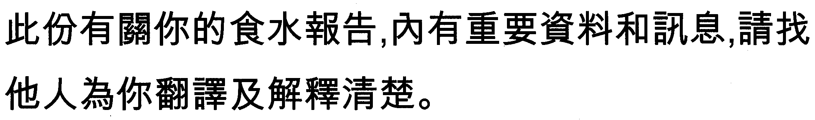
Chinese (Simplified)
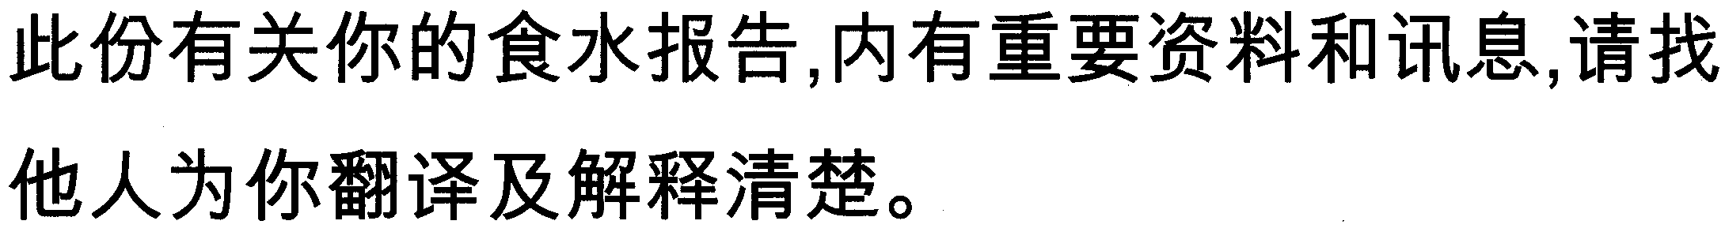
Farsi
French
Cé rapport contient des information importantes concernant votre eau potable. Veuillez traduire, ou parlez avec quelqu' un qui peut le comprendre.
German
Dieser Bericht enthält wichtige Information über Ihr Trinkwasser. Bitte übersetzen Sie ihn oder sprechen Sie mit jemandem, der ihn versteht.
Greek
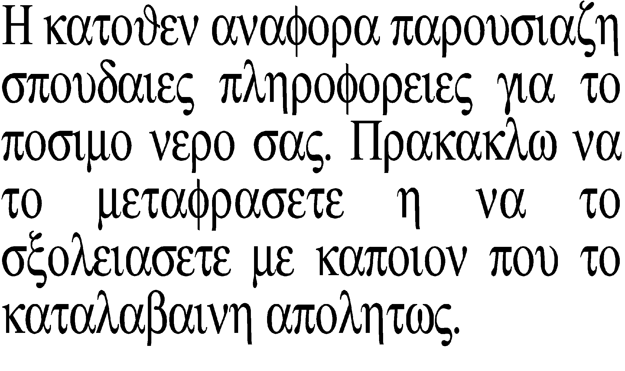

Hebrew
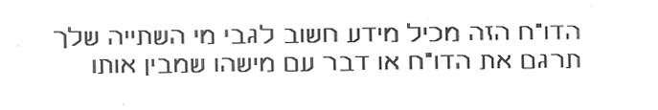
Hindi
Hmong
Daimntawv tshaj tawm no muaj lus tseemceeb txog koj cov dej haus. Tshab txhais nws, los yog tham nrog tej tug neeg uas totaub txog nws.
Irish
Tá eolas tábhachtach san tuairisc faoi uisce inólta. Aistrigh é, nó labhair le duine cé a thuigeann é.
Italian
Questo rapporto contiene informazioni inportanti che riguardano la vostra aqua potabile. Traducetelo, o parlate con una persona qualificata in grado di spiegarvelo.
Japanese
この報告書には上水道に関する重要な情報が記されております。翻訳を御依頼なされるか、内容をご理解なさっておられる方にお尋ね下さい。
Khamer

Korean
Laotion
Polish
Ta broszura zawiera wazne informacje dotyczace jakosci wody do picia. Przetlumacz zawartosc tej broszury lub skontaktuj sie z osoba ktora pomoze ci w zrozumieniu zawartych informacji.
Punjabi
Russian
Этот отчет содержит важную информацию о вашей питьевой воды. Переведите его или поговорите с тем, кто это понимает.
Swahili
Shauri hii niya kufahamisha uzuri wa maji ya kunyua. Shauri nilazima egeuzwe kwa yoyote hajui Kiingereza.
Tagalog
Mahalaga ang impormasyong ito. Mangyaring ipasalin ito.
Turkish
Bu rapor içme suyunuzla ilgili önemli bilgi içermektedir. Bunu tercüme edin veya anlayan biri ile görüşün.
Vietnamese

Appendix F: Source Water Protection and Water Conservation Tips for Consumers
Source Water Protection Tips for Consumers – Example Language
Protection of drinking water is everyone’s responsibility. You can help protect your community’s drinking water source in several ways:
- Eliminate excess use of lawn and garden fertilizers and pesticides – they contain hazardous chemicals that can reach your drinking water source.
- Pick up after your pets.
- If you have your own septic system, properly maintain your system to reduce leaching to water sources or consider connecting to a public water system.
- Dispose of chemicals properly; take used motor oil to a recycling center.
- Volunteer in your community. Find a watershed or wellhead protection organization in your community and volunteer to help. If there are no active groups, consider starting one. Use USEPA’s Adopt Your Watershed to locate groups in your community, or visit the Watershed Information Network’s How to Start a Watershed Team.
- Organize a storm drain stenciling project with your local government or water supplier. Stencil a message next to the street drain reminding people “Dump No Waste – Drains to River” or “Protect Your Water”. Produce and distribute a flyer for households to remind residents that storm drains dump directly into your local water body.
Water Conservation Tips for Consumers
Did you know that the average U.S. household uses approximately 400 gallons of water per day or 100 gallons per person per day? Luckily, there are many low-cost and no-cost ways to conserve water. Small changes can make a big difference – try one today and soon it will become second nature.
- Take short showers – a 5 minutes shower uses 4 to 5 gallons of water compared to up to 50 gallons for a bath.
- Shut off water while brushing your teeth, washing your hair, and shaving and save up to 500 gallons a month.
- Use a water-efficient showerhead. They are inexpensive, easy to install, and can save you up to 750 gallons a month.
- Run your clothes washer and dishwasher only when they are full. You can save up to 1,000 gallons a month.
- Water plants only when necessary.
- Fix leaking toilets and faucets. Faucet washers are inexpensive and take only a few minutes to replace. To check your toilet for a leak, place a few drops of food coloring in the tank and wait. If it seeps into the toilet bowl without flushing, you have a leak. Fixing it or replacing it with a new, more efficient model can save up to 1,000 gallons a month.
- Adjust sprinklers so only your lawn is watered. Apply water only as fast as the soil can absorb it and during the cooler parts of the day to reduce evaporation.
- Teach your kids about water conservation to ensure a future generation that uses water wisely. Make it a family effort to reduce next month’s water bill!
- Visit www.epa.gov/watersense for more information.

