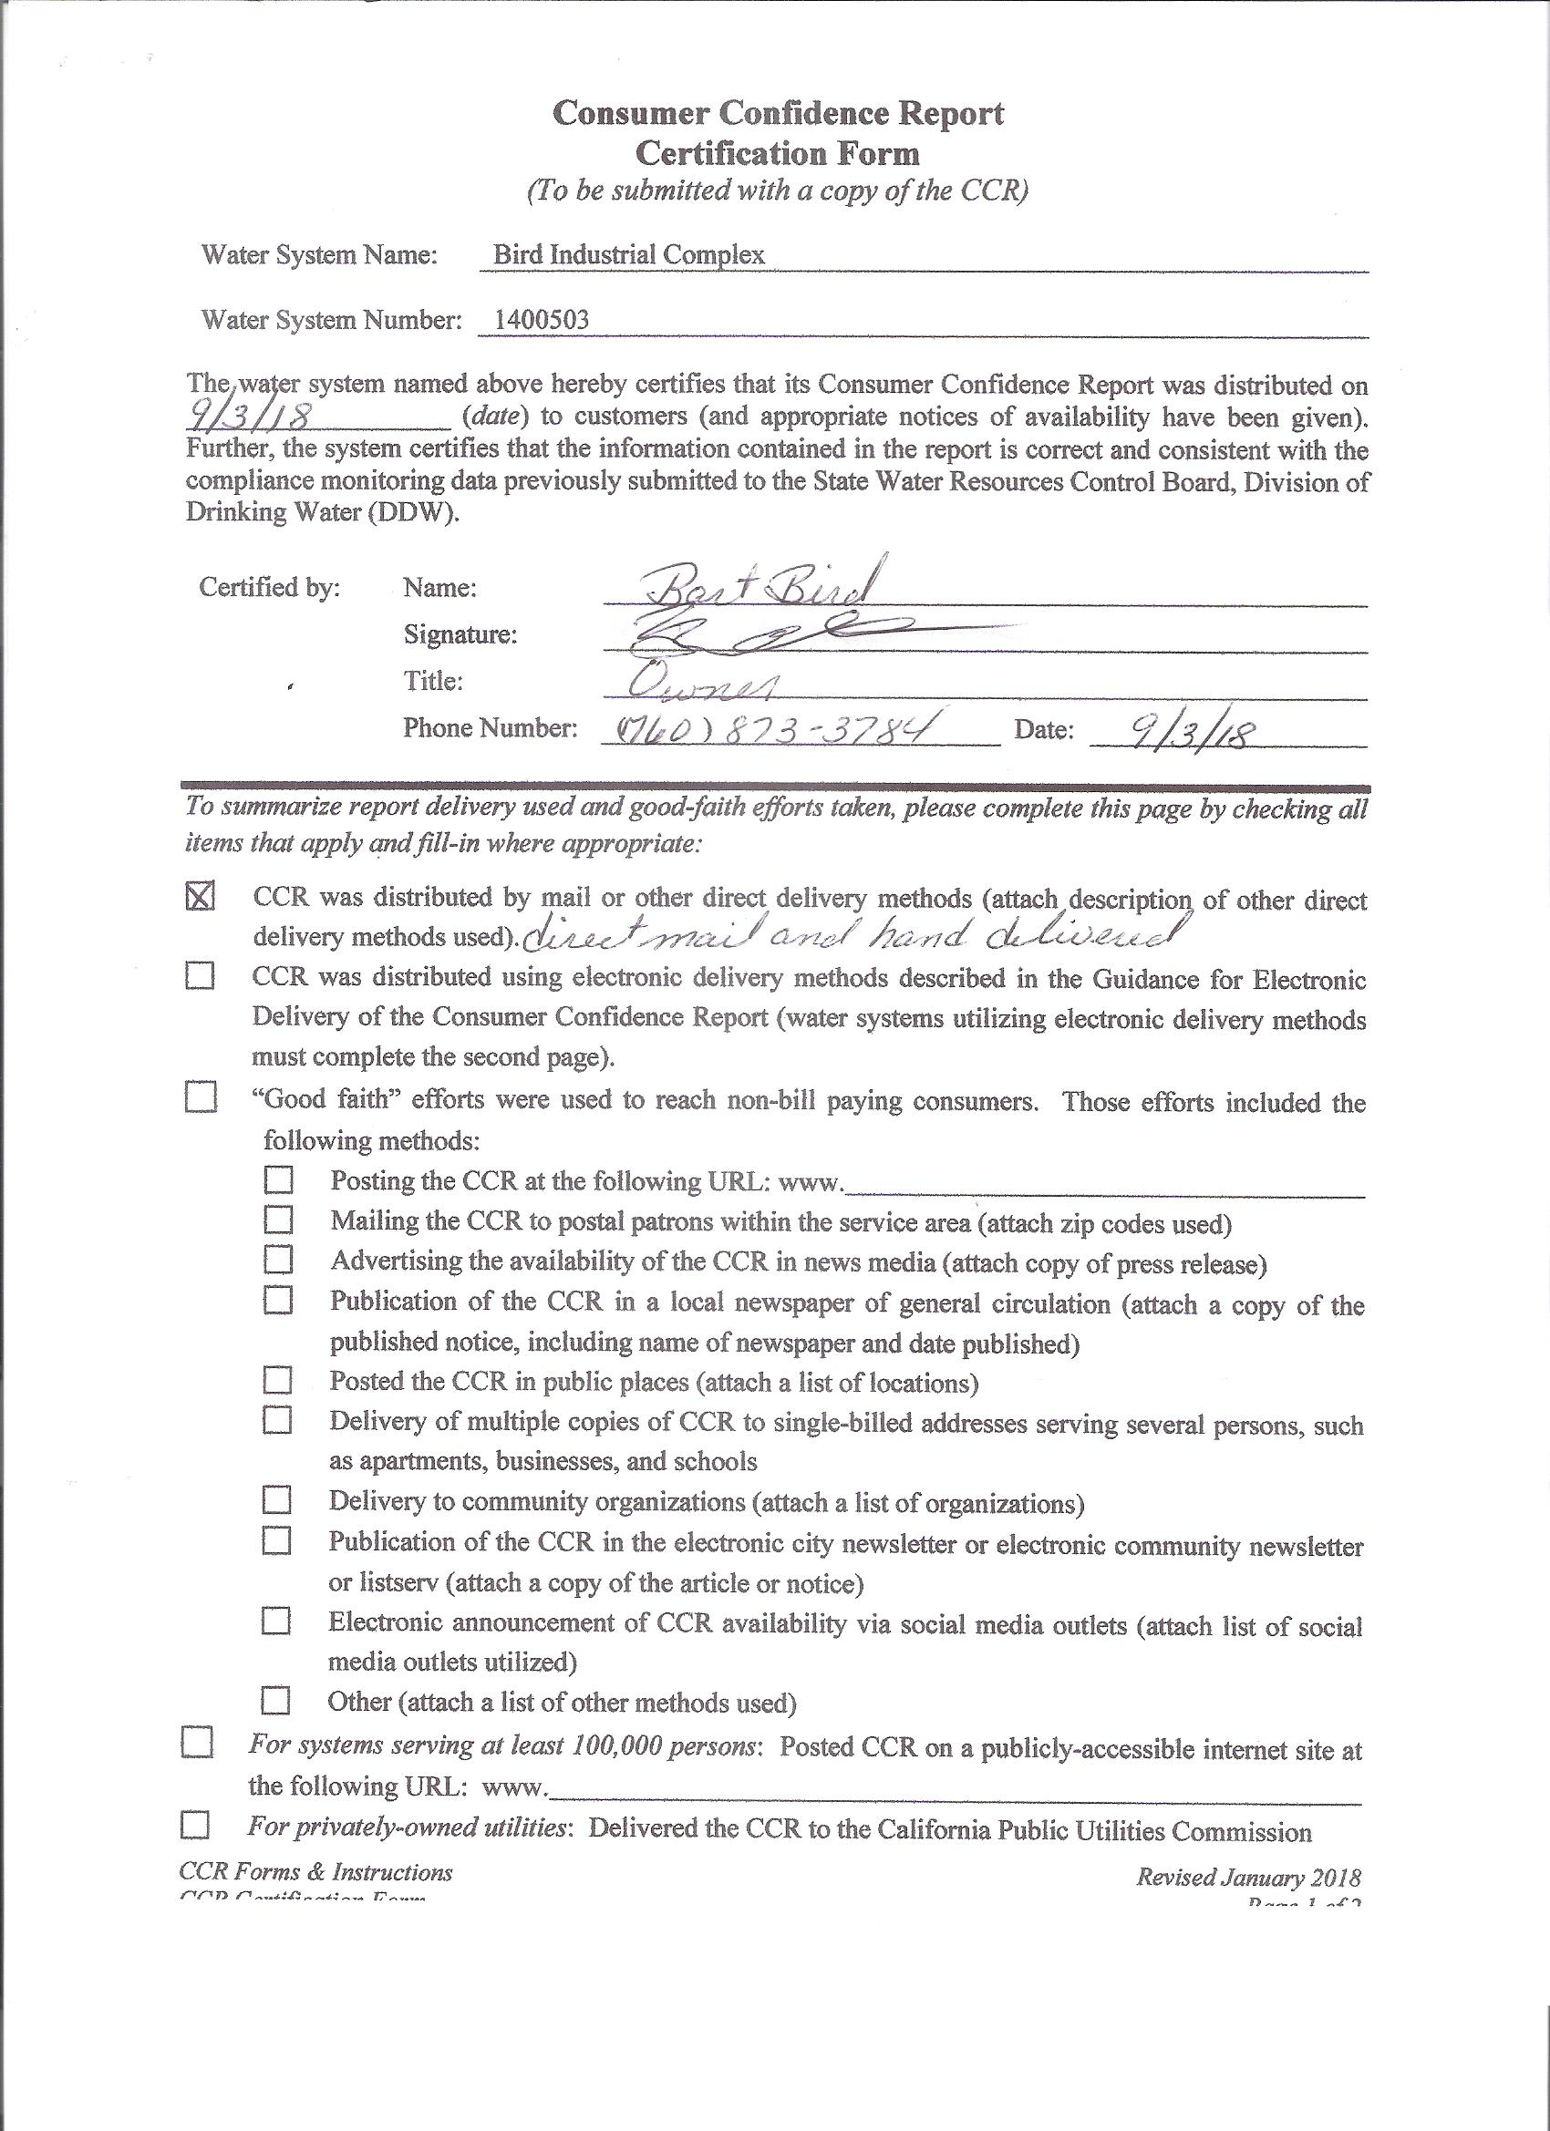

2017 Consumer Confidence Report
Water System Name: | Bird Industrial Complex, LLC | Report Date: | June 18, 2018
We test the drinking water quality for many constituents as required by State and Federal Regulations. This report shows the results of our monitoring for the period of January 1 - December 31, 2017.
Este informe contiene información muy importante sobre su agua potable. Tradúzcalo ó hable con alguien que lo entienda bien.
Type of water source(s) in use: | Groundwater well.
Name & location of source(s): | Well 01 is located at the industrial complex.
Drinking Water Source Assessment information: |  | The source water assessment was updated in June 2011.
The source is considered to be most vulnerable to the following activities associated with nitrate detections: on-site septic systems and cattle grazing in pastures. The source is considered to be vulnerable to the following activities not associated with any detected contaminants: chemical/petroleum processing/storage, plastics/synthetics producers, known contaminant plumes at historic fuel tank site, confirmed leaking underground storage tanks. A copy of the complete assessment may be viewed at the Inyo County Environmental Health Services, 207 W. South St, Bishop, or call (760) 873-7865.
Time and place of regularly scheduled board meetings for public participation: |  |  |  |  | Not applicable.
For more information, contact: | Bart Bird |  |  | Phone: |  | (760) 873-3784
TERMS USED IN THIS REPORT:
Maximum Contaminant Level (MCL): The highest level of a contaminant that is allowed in drinking water. Primary MCLs are set as close to the PHGs (or MCLGs) as is economically and technologically feasible. Secondary MCLs are set to protect the odor, taste, and appearance of drinking water.  Maximum Contaminant Level Goal (MCLG): The level of a contaminant in drinking water below which there is no known or expected risk to health. MCLGs are set by the U.S. Environmental Protection Agency (USEPA).  Public Health Goal (PHG): The level of a contaminant in drinking water below which there is no known or expected risk to health. PHGs are set by the California Environmental Protection Agency.  Maximum Residual Disinfectant Level (MRDL): The level of a disinfectant added for water treatment that may not be exceeded at the consumer’s tap.  Maximum Residual Disinfectant Level Goal (MRDLG): The level of a disinfectant added for water treatment below which there is no known or expected risk to health. MRDLGs are set by the U.S. Environmental Protection Agency. |  |  | Primary Drinking Water Standards (PDWS): MCLs and MRDLs for contaminants that affect health along with their monitoring and reporting requirements, and water treatment requirements.  Secondary Drinking Water Standards (SDWS): MCLs for contaminants that affect taste, odor, or appearance of the drinking water. Contaminants with SDWSs do not affect the health at the MCL levels.  Treatment Technique (TT): A required process intended to reduce the level of a contaminant in drinking water.  Regulatory Action Level (AL): The concentration of a contaminant which, if exceeded, triggers treatment or other requirements that a water system must follow.  Variances and Exemptions: Department permission to exceed an MCL or not comply with a treatment technique under certain conditions.  ND: not detectable at testing limit  ppm: parts per million or milligrams per liter (mg/L)  ppb: parts per billion or micrograms per liter (ug/L)  ppt: parts per trillion or nanograms per liter (ng/L)  pCi/L: picocuries per liter (a measure of radiation)
The sources of drinking water (both tap water and bottled water) include rivers, lakes, streams, ponds, reservoirs, springs, and wells. As water travels over the surface of the land or through the ground, it dissolves naturally-occurring minerals and, in some cases, radioactive material, and can pick up substances resulting from the presence of animals or from human activity.
Contaminants that may be present in source water include:
- Microbial contaminants, such as viruses and bacteria, that may come from sewage treatment plants, septic systems, agricultural livestock operations, and wildlife.
- Inorganic contaminants, such as salts and metals, that can be naturally-occurring or result from urban stormwater runoff, industrial or domestic wastewater discharges, oil and gas production, mining, or farming.
- Pesticides and herbicides, that may come from a variety of sources such as agriculture, urban stormwater runoff, and residential uses.
- Organic chemical contaminants, including synthetic and volatile organic chemicals, that are byproducts of industrial processes and petroleum production, and can also come from gas stations, urban stormwater runoff, agricultural application, and septic systems.
- Radioactive contaminants, that can be naturally-occurring or be the result of oil and gas production and mining activities.
In order to ensure that tap water is safe to drink, the USEPA and the state Department of Health Services (Department) prescribe regulations that limit the amount of certain contaminants in water provided by public water systems. Department regulations also establish limits for contaminants in bottled water that must provide the same protection for public health.
Tables 1, 2, 3, 4, 5 and 6 list all of the drinking water contaminants that were detected during the most recent sampling for the constituent. The presence of these contaminants in the water does not necessarily indicate that the water poses a health risk. The Department allows us to monitor for certain contaminants less than once per year because the concentrations of these contaminants do not change frequently. Some of the data, though representative of the water quality, are more than one year old.

Table 1 - sampling results showing the detection of coliform bacteria
Microbiological Contaminants | Highest No. of detections | No. of months in violation |  | MCL |  | MCLG | Typical Source of Bacteria
*Total Coliform Bacteria | (In a mo.)  1 | 0 |  | More than 1 sample in a month with a detection |  | 0 | Naturally present in the environment
Fecal Coliform or E. coli | (In the year)  0 | 0 |  | A routine sample and a repeat sample detect total coliform and either sample also detects fecal coliform or E. coli |  | 0 | Human and animal fecal waste

Table 2 - sampling results showing the detection of Lead and copper
Lead and Copper | No. of samples collected |  | 90th percentile level detected | No. sites exceeding AL | AL | PHG | Typical Source of Contaminant
Lead (ppb)  2016 | 5 |  | 2.1 | 0 | 15 | 0.2 | Internal corrosion of household water plumbing systems; discharges from industrial manufacturers; erosion of natural deposits
Copper (ppm)  2016 | 5 |  | 0.128 | 0 | 1.3 | 0.3 | Internal corrosion of household plumbing systems; erosion of natural deposits; leaching from wood preservatives

TAble 3 - sampling results for sodium and hardness
Chemical or Constituent (and reporting units) | Sample Date |  | Level Detected | Range of Detections | MCL | PHG  (MCLG) | Typical Source of Contaminant
Sodium (ppm) | 1/17/86 |  | 47 | n/a | none | none | Generally found in ground & surface water
Hardness (ppm) | 1/17/86 |  | 188 | n/a | none | none | Generally found in ground & surface water
*Any violation of an MCL or AL is marked with an asterisk. Additional information regarding the violation is provided later in this report.
TAble 4 - detection of contaminants with a Primary Drinking Water Standard
Chemical or Constituent  (and reporting units) |  | Sample Date |  | Level Detected | Range of Detections |  | MCL  [MRDL] |  | PHG  (MCLG)  [MRDLG] |  | Typical Source of Contaminant
Arsenic (ppb) |  | 8/3/16 |  | 4.0 | n/a |  | 10 |  | 0.004 |  | Erosion of natural deposits
Fluoride (ppm) |  | 8/27/07 |  | 0.2 | n/a |  | 2.0 |  | 1 |  | Erosion of natural deposits
Gross Alpha (pCi/L) |  | 8/24/15 |  | 6.8 | n/a |  | 15 |  | (0) |  | Erosion of natural deposits
Nitrate as N (ppm) |  | 7/24/17 |  | 0.8 | n/a |  | 10 |  | 10 |  | Runoff and leaching from fertilizer use; leaching from septic tanks and sewage; erosion of natural deposits
Uranium (pCi/L) |  | 8/24/15 |  | 5.7 | n/a |  | 20 |  | 0.43 |  | Erosion of natural deposits
TAble 5 - detection of contaminants with a Secondary Drinking Water Standard
Chemical or Constituent  (and reporting units) |  | Sample Date |  | Level Detected | Range of Detections |  | MCL |  | PHG  (MCLG) |  | Typical Source of Contaminant
Chloride (ppm) |  | 1/17/86 |  | 20 | n/a |  | 500 |  | n/a |  | Erosion of natural deposits
Specific Conductance (uS/cm) |  | 6/8/94 |  | 630 | n/a |  | 1600 |  | n/a |  | Substances that form ions when in water
Sulfate (ppm) |  | 1/17/86 |  | 130 | n/a |  | 500 |  | n/a |  | Erosion of natural deposits
Total Dissolved Solids (ppm) |  | 1/17/86 |  | 432 | n/a |  | 1000 |  | n/a |  | Erosion of natural deposits
Zinc (ppm) |  | 1/18/00 |  | 0.054 | n/a |  | 5 |  | n/a |  | Erosion of natural deposits
TAble 6 – detection of UNREGULATED CONTAMINANTS
Chemical or Constituent  (and reporting units) | Sample Date |  | Level Detected |  |  | Range of Detections |  | Notification Level |  | Health Effects Language
Vanadium (ppb) | 8/3/16 |  | 3 |  |  | n/a |  | 50 |  | The babies of some pregnant women who drink water containing vanadium in excess of the notification level may have an increased risk of developmental effects, based on studies in laboratory animals.

*Any violation of an MCL, MRDL, or TT is asterisked. Additional information regarding the violation is provided later in this report.
Additional General Information on Drinking Water
Drinking water, including bottled water, may reasonably be expected to contain at least small amounts of some contaminants. The presence of contaminants does not necessarily indicate that the water poses a health risk. More information about contaminants and potential health effects can be obtained by calling the USEPA’s Safe Drinking Water Hotline (1-800-426-4791).
Some people may be more vulnerable to contaminants in drinking water than the general population. Immuno-compromised persons such as persons with cancer undergoing chemotherapy, persons who have undergone organ transplants, people with HIV/AIDS or other immune system disorders, some elderly, and infants can be particularly at risk from infections. These people should seek advice about drinking water from their health care providers. USEPA/Centers for Disease Control (CDC) guidelines on appropriate means to lessen the risk of infection by Cryptosporidium and other microbial contaminants are available from the Safe Drinking Water Hotline (1-800-426-4791).
Summary Information for Contaminants Exceeding an MCL, MRDL, or AL, or a Violation of Any Treatment Technique or Monitoring and Reporting Requirement
VIOLATION OF A MCL, MRDL, AL, TT, OR MONITORING AND REPORTING REQUIREMENT
Violation | Explanation | Duration | Actions Taken to Correct the Violation | Health Effects Language
Consumer Confidence Report Violation | We failed to distribute a CCR for the 2016 calendar year. | 2016 | Distributing this 2017 CCR will bring us back in to compliance. | The health effects of this violation are unknown.

